2. Design Zero-shot, One-shot, and Few-shot Prompts to Generate a 200-word Blog on “Applications of Artificial Intelligence in Healthcare”
A. Zero-shot Prompt
Prompt:
Write a blog of approximately 200 words on “Applications of Artificial Intelligence in Healthcare.” Explain how AI is used in disease diagnosis, medical imaging, drug discovery, patient monitoring, and personalized treatment. Use simple language and an informative tone.
Expected Output:
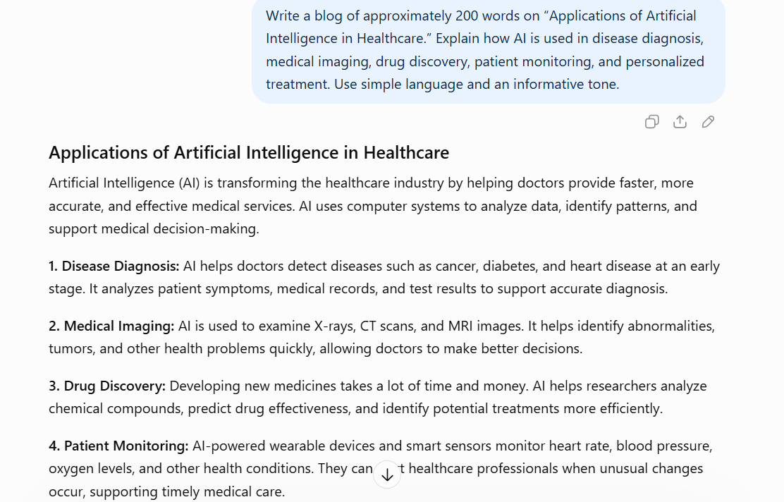
B. One-shot Prompt
Prompt:
Example:
Topic: Benefits of Online Education
Blog: Online education makes learning flexible and accessible. Students can attend classes from different locations, access digital resources, and learn at their own pace. It also supports communication through online platforms and reduces travel time.
Now write a blog of approximately 200 words on “Applications of Artificial Intelligence in Healthcare.” Discuss disease diagnosis, medical imaging, drug discovery, patient monitoring, and personalized treatment. Follow the example's simple and informative writing style.
Expected Output:
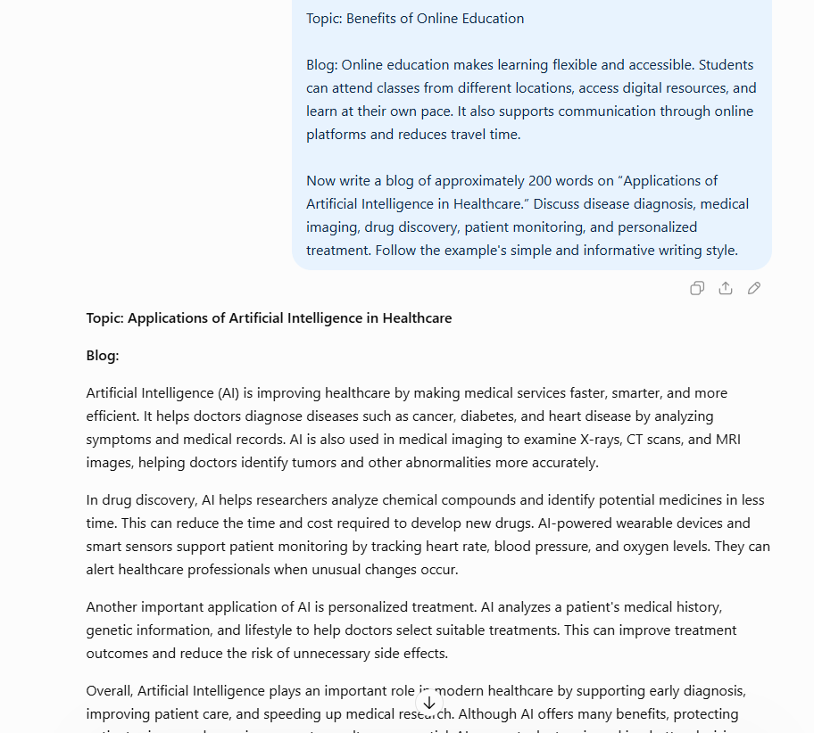
C. Few-shot Prompt
Prompt:
Example 1:
Topic: Applications of Technology in Education
Blog: Technology supports education through digital classrooms, online learning platforms, and interactive learning materials. It helps students access information and communicate with teachers.
Example 2:
Topic: Applications of Technology in Agriculture
Blog: Technology helps farmers monitor crops, manage irrigation, predict weather conditions, and improve productivity. Modern tools support more efficient agricultural practices.
Example 3:
Topic: Applications of Technology in Transportation
Blog: Technology improves transportation through navigation systems, traffic monitoring, and intelligent transport management. These applications help improve travel efficiency and safety.
Now write a blog of approximately 200 words on “Applications of Artificial Intelligence in Healthcare.” Cover disease diagnosis, medical imaging, drug discovery, patient monitoring, and personalized treatment. Use an introduction, main body, and conclusion.
Expected Output:
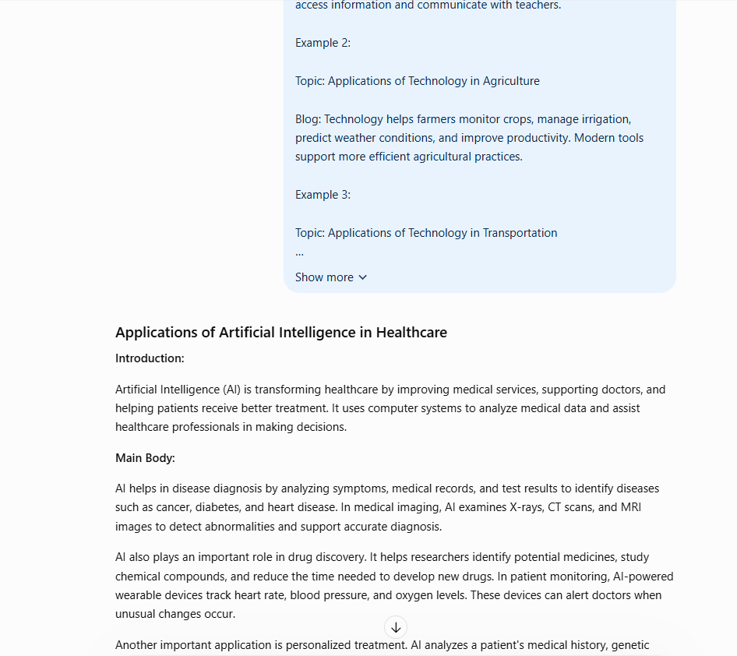

D. Comparison
Technique | Advantage
Zero-shot | Generates content directly from instructions.
One-shot | Uses one example to guide the writing style.
Few-shot | Uses multiple examples to guide structure and consistency.

Result:
All three prompting techniques can generate a healthcare blog. One-shot and few-shot prompts provide additional guidance about writing style and organization.

